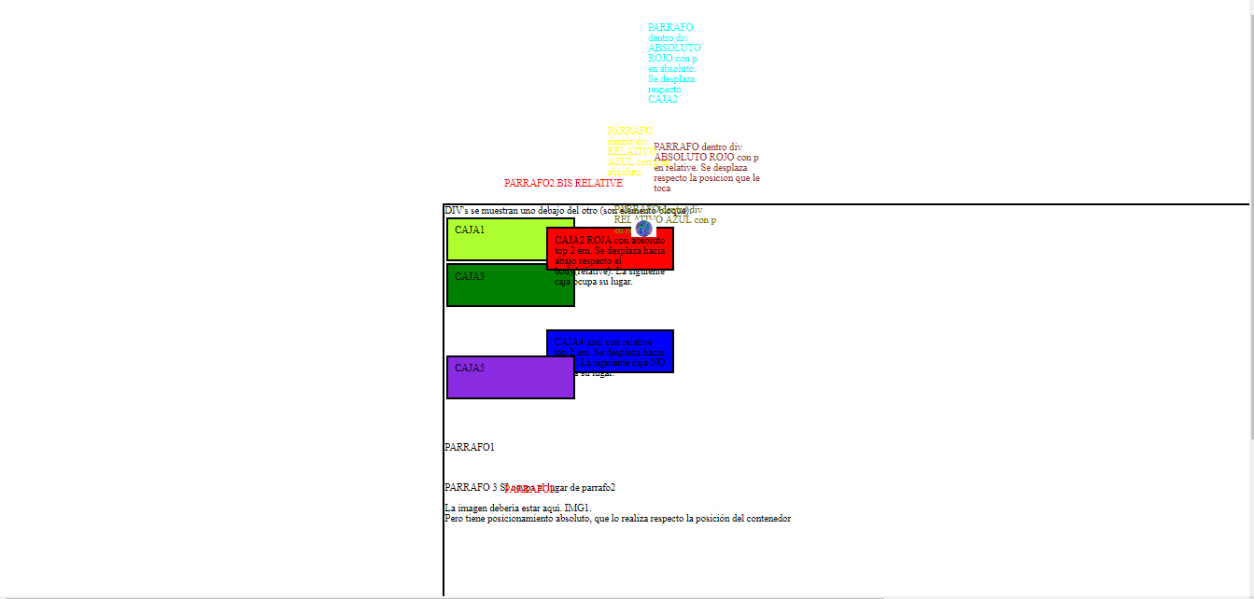

45em

20em

<body style="border: 3px solid black; position: relative; top:20em;left:45em">

